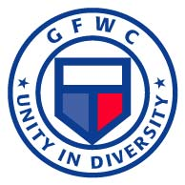 | JWCC News  The GFWC Junior Woman’s Civic Club of  Cumberland, Maryland Inc.
October 2011 | Working in our communities for 64 years
In This Issue  Meeting Agenda  Ditty Bag Items List  Refreshment Hostesses  Festival of Trees  This Day in History  GFWC History  Quote of the Month  Birthdays  Recipe  Domestic Violence Links  www.ncadv.org  www.ndvh.org  www.loveisrespect.org  Other Useful Links  www.history.com  www.earthday.net  Contact Us  http://www.gfwc.org or  terry@terryharvey.net  Remember to bring:  - Ditty Bag Items  - Fundraising Ideas  - Dues  - A friend  Mark the Dates:  October 8- Junior Fall Conference, Bethesda  November 3-6- Southeastern Region Meeting, Lexington, KY  November 15- GFWC-MD Board of Directors, Frederick  Do you have a great JWCC photo? If so, we want them for the newsletter. Please forward your digital photo to kimiller@verizon.net or bring a copy to a club meeting and we will scan and return. |  | President’s Corner  Hello Fellow Clubwomen, We missed several of you at the last meeting. There is much happening and much to plan. I have a tentative agenda for October’s meeting. It is included in this newsletter as well as the ditty bag list and the refreshment sign up. Membership dues will be collected - remember the membership basket! Pay your dues early for more chances to win the lovely basket.  We need ideas for fundraisers- a few suggestions are listed. Any suggestion you may have are welcomed.  We need to decide at this meeting if we plan to do the Plays. We will vote that night and decide- so if you are not able to attend please send your vote with someone or let one of the board members know.  Remember your ditty bag items, fundraising ideas, membership dues, and a FRIEND! If you haven’t completed your membership form so Sandra can get our membership booklet updated, bring that as well. If you need a form let me know. Hope to see you all at the meeting October 5.  In Federation Friendship, Terry  Agenda – General Meeting (bring this to our meeting)  GFWC/JWCC of Cumberland, Inc.  Wednesday, October 5 , 2011  - Call to Order  - Flag Salute  - Minutes of the Previous Meeting  - Treasurer’s Report  - Program- Ditty Bags  - Unfinished Business  - Refreshment sign up for the year- Need February and the Progressive Dinner filled.  - Membership Basket/Dues $35  - Polo Shirts  - Plays- March 18, 2012- we need to decide tonight.  - March of Dimes- Debbie Harris- Tree Donation, Festival of Trees, Ladies Night Out (Nov 11)  - Salvation Army- Bell ringing and gift bags  - Santa’s Workshop- ?  - Upcoming Events  - October 8- Junior Fall Conference, Chevy Chase  - October 22- Western District Meeting, Riding Club, Westminster  - November 3-6- Southeastern Region Meeting, Lexington, KY  - November 15- GFWC-MD Board of Directors, Frederick  - New Business  - Unicef Boxes- Due November meeting  - Fundraising ideas- Longaberger (Melissa), Mary Kay (Renae), Gas card (Martins/Sheetz), GFWC Coffee, GFWC Pecans, other ideas.  - Project- Collaboration with Make-A-Wish & Jenna (Fundraising Ideas)  - Scholarship Recipient will be at the December meeting.  - Correspondence  - Collect  - Adjourn  Ditty Bag Project  Please join us at this meeting and help us to complete our ditty bag project. Please don’t forget to bring the following items or any other small items that may offer a veteran comfort or entertainment:  Puzzle Books, tissues- Beth  Playing cards- Jo  Pen and Pad- Vicki  Toothbrushes- Mary Beth  Hand sanitizer- Debbie S.  Small bottles of water, ink pens, post it notes- Debbie H.  Misc hotel items- Debbie H.  Pens, Pencils, deodorant, hand sanitizer, Kleenex, lemonade packets- Debbie H.  Misc items- Marilyn, Regina, & Joyce  Diana- Freeze pops  Terry- chapstick, tic tacs, Cinnamon gum  Refreshment Hostesses  October- Mary Beth & Beth  November- Terry, Diana, & Renae  December- Joyce, Vicki, Madison & Blair  January- Reports  February  March- Marilyn & Debbie  April (Progressive Dinner)  May- Regina, Debbie, & Caroline  June- Dinner out!  Festival of Trees  JWCC is once again supporting the March of Dimes’ Festival of Trees fundraiser at the Country Club mall. 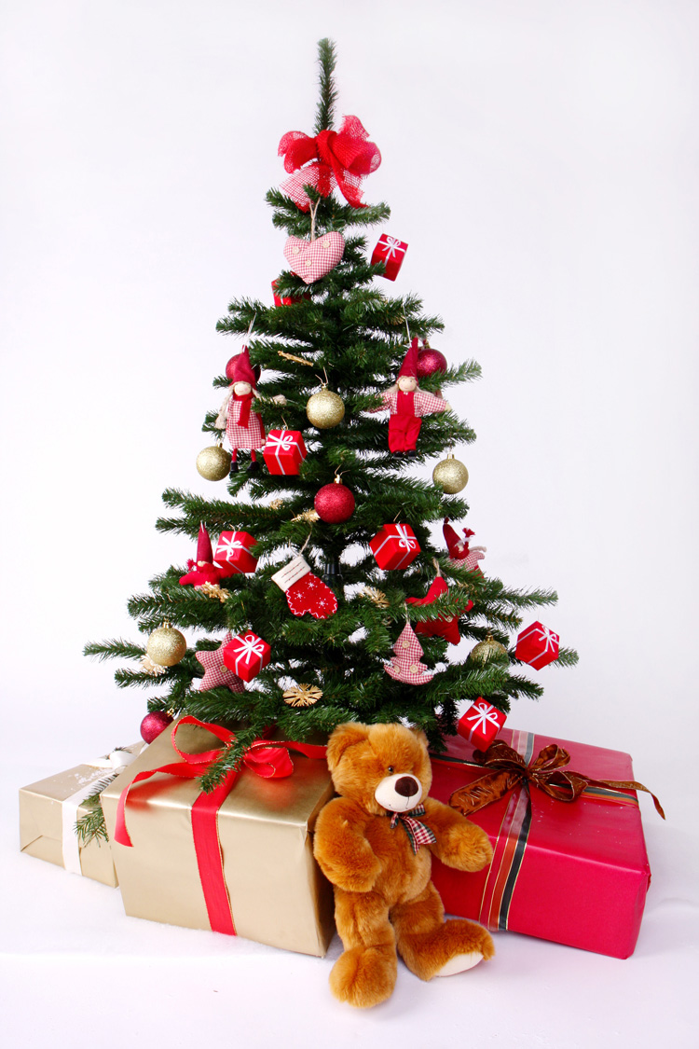Please review the list of dates below and contact Debbie Harris if you can participate. Ask a fellow clubwoman to join you and double your fun!  Day Date Time  Thurs Nov 17 5 - 9 (Opening)  Fri Nov 18 11- 2  2 - 5  5 - 8  Sat Nov 19 11- 2  2 - 5  5 – 8  Sun Nov 20 12 - 3  3 - 6  Mon Nov 21 11 - 2  2 - 5  5 - 8  Tues Nov 22 11 - 2  2 - 5  5 - 8  Wed Nov 23 11 - 2  2 - 5  5 - 8  Thurs CLOSED THANKSGIVING  Fri Nov 25 11 - 2  2 - 5  5 - 8  Sat Nov 26 11 - 2  2 - 5  5 - 8  Sun Nov 27 12 - 3  3 - 6  Mon Nov 28 11 - 2  2 - 5  5 - 8  Tues Nov 29 11 - 2  2 - 5  5 - 8  Wed Nov 30 11 - 2  2 - 5  5 - 8  Thurs Dec 1 11 - 2  2 - 5  5 - 8  Fri Dec 2 11 - 2  2 - 5  5 - 8  Sat Dec 3 11 - 2  2 - 5  5 - 8  Sun Dec 4 12 - 3  3 - 6 (Closing)  This Day in History  1947 – First Presidential speech on TV  1953 – Yankees win their fifth World Series in a row  1986 – Iran-Contra scandal unravels  1991 – Marky Mark and the Funky Bunch hit #1 with song “Good Vibrations”  GFWC History  1986: In keeping with GFWC's commitment to conservation, the Federation instituted programs to protect and preserve endangered species.  (source www.gfwc.org)  Member Update  No updates at this time  Quote of the Month  “I think it's about time we voted for senators with breasts. After all, we've been voting for boobs long enough.”  ~ Clarie Sargent, Arizona senatorial candidate  Happy Birthday Greetings  Oct 28 – Sandra Mattocks  Recipe – National Caramel Month  (source: Paula Deen, Food Network, www.foodnetwork.com)  Caramel and Spice Latte  Ingredients  3/4 cup hot espresso  1/3 cup half-and-half  2 teaspoons caramel ice cream topping  Dash apple pie spice  Whipped cream, for garnish  Directions  In a serving glass or mug, combine the hot espresso, half-and-half, caramel topping, and apple pie spice. Stir to combine and garnish with whipped cream

